How teens use media in the US
Activité langagière travaillée et objectifs :  - Entrainement à la compréhension écrite et à l’expression écrite  - Comprendre le sens d’un article de presse  - Lire et interpréter un diagramme | Liens avec le programme :  - langages  - rencontres avec d’autres cultures | Niveaux du CECRL : A2-> B1  Socle (S4C) : domaines 1, 3  Classe(s) : 4ème LV1, 3ème LV2
Document(s) et source(s) : New Hi there !, cycle 4, 4ème
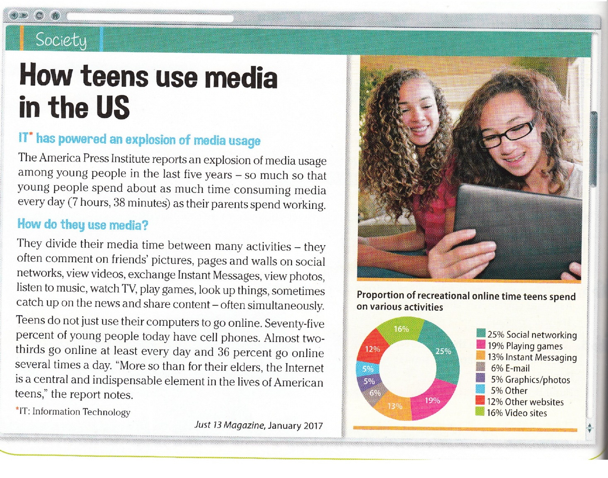

Activité à transmettre au professeur via l’ENT (casier) ou Pronote (ou tout autre moyen).
1 : Read the title of the document, look at the picture and answer the wh-questions:
- Who? : …………………………………………………………… Where?: ………………………………………… What?: …………………………………………………………………………
2 : Read the text and pick out :
- the transparent words and the words you know: ……………………………………………………………………………………………………………………………………………….
- the repetitions: …………………………………………………………………………………………………………………………………………………………………………………………………..
3 : List the activities and media mentioned in the text:
- Activities: ………………………………………………………………………………………………………………………………………………………………………………………………………
- Media: ……………………………………………………………………………………………………………………………………………………………………………………………………………..
4 : In the second paragraph, pick out :
- the verbs : …………………………………………………………………………………………………………………………………………………………………………………………………………
5 : In the third paragraph, pick out :
- the numbers : ……………………………………………………………………………………………………………………………………………………………………………………………….
6: Conclusion: write 2 sentences about teens’ media habits in the USA.
……………………………………………………………………………………………………………………………………………………………………………………………………………………………………
……………………………………………………………………………………………………………………………………………………………………………………………………………………………………..
7: Read the graph (= diagram) and write 2 sentences about online time teens spend on activities.
……………………………………………………………………………………………………………………………………………………………………………………………………………………………………
……………………………………………………………………………………………………………………………………………………………………………………………………………………………………..
8: Write 2 sentences about your online activities:
……………………………………………………………………………………………………………………………………………………………………………………………………………………………………
……………………………………………………………………………………………………………………………………………………………………………………………………………………………………..

