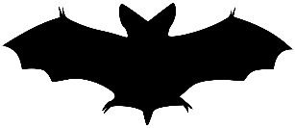
A STRANGE ARRIVAL
Cette photo par Auteur inconnu est soumise à la licence CC BY-SA

Jonathan Harker, a young sollicitor and the narrator, has come from London to visit Count Dracula as the Count wants to buy a property in London. He has just arrived at the castle and is recollecting his journey.
5 May.-The Castle.-

The grey of the morning has passed, and the sun is high over the distant horizon, which seems jagged, whether with trees or hills I know not, for it is so far off that big things and little are mixed. I am not sleepy, and, as I am not to be called till I awake, naturally I write till sleep comes. There are many odd things to put down, and, lest [the one] who reads them may fancy that I dined too well before I left Bistritz, let me put down my dinner exactly. I dined on what they call “robber steak”- bits of bacon, onion, and beef, seasoned with red pepper, and strung on sticks and roasted over the fire […]The wine was Golden Mediasch […] I had only a couple of glasses of this and nothing else.
When I got on the coach the driver had not taken his seat, and I saw him talking with the landlady. They were evidently talking of me, for every now and then they looked at me, and some of the people who were sitting on the bench outside the door_ which they call by a name meaning “word-bearer”_ came and listened and then they looked at me, most of them pityingly. I could hear a lot of words often repeated, queer words, for there were many nationalities in the crowd; so I quietly got my polyglot dictionary from my bag and looked them out. I must say they were not cheering to me, for amongst them were “Ordog”_Satan, “pokol”_hell, “strgoica”_witch, “vrolok” and “vlkoslak”_ both of which mean the same thing, one being Slovak and the other Servian for something that is either were-wolf or vampire.( Mem, I must ask the Count about these superstitions.)
When we started, the crowd round the inn door, which had by this time swelled to a considerable size, all made the sign of the cross and pointed two fingers towards me. With some difficulty I got a fellow passenger to tell me what they meant; he would not answer at first, but on learning that I was English, he explained that it was a charm or guard against the evil eye. This was not very pleasant for me, just starting for an unknown place to meet an unknown man; but everyone seemed so kind-hearted, and so sorrowful, and so sympathetic that I could but be touched. I shall never forget the last glimpse that I had of the inn-yard and its crowd of picturesque characters, all crossing themselves […].
Then our driver cracked his big whip over his four small horses, which ran abreast, and we set off on our journey.
Adapted from DRACULA by Bram STOKER, 1897.

WEBQUEST
- Find some information about Bram Stoker ( nationality? date of birth and death? His studies? )
- The origins of “Count Dracula”:
- Where does the name come from?
- What does “Dracula” mean?
- Vampires :
- What do you know about their physical appearance ? their supernatural powers and their limitations?
- Give a short definition of “Gothic novel”.
- Find three British or American writers who wrote Gothic novels.

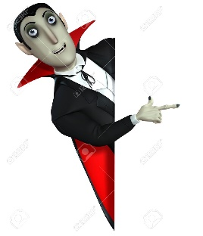
Understanding the text
Read the text as many times as necessary, and answer the questions underneath.
- The text: nature? Genre ? Narrator?
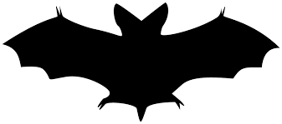
2-The story: a- who? when? where? (make suppositions from elements that you find in the text if you don’t have the precise answer..)
- Explain the situation and what is happening in this excerpt.
- Describe the narrator’s feelings ( highlight the adjectives and adverbs and draw conclusions…)
- Now explain why this passage is typical of gothic novels.
- How does the author arouse the reader’s curiosity and appeal to his imagination in this excerpt?

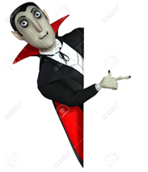
- WRITTEN EXPRESSION

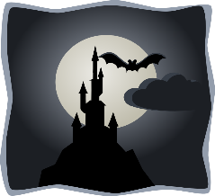
- You are Count Dracula. Jonathan Harker has just arrived from London to your castle. You have taken him to his room for the night. Write the entry in Count Dracula’s diary in which you tell about the arrrival of the British sollicitor Jonathan Harker in Transylvania and at the castle. You also express your first impressions about the young man. (200 words minimum, respect the tone and features of a gothic novel and try your best to arouse the reader’s curiosity)

5 May. The Castle
……………………………………………………………………………….
………………………………………………

