SODASTREAM CRYSTAL DRINK MAKER

FEATURES

£134.45
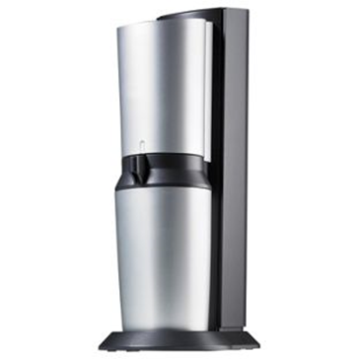
- an elegant high end way to prepare and serve your sparkling drinks.
- the only sparkling water maker in the current range that allows you to use a glass bottle
Included :
- an elegant Glass Carafe for carbonating your drink --dishwasher safe.
- 1. 60 litres gas cylinder supplied (makes up to 60 litres of your favourite sparkling drinks)
- Includes 1 carbonating bottle with a 1 litre capacity.

- Size : H44, W15.5, D26.5cm.

- Weight : 2.8kg

Special offer : Buy now, pay 6 Months later or Buy now, pay 3 Months later when you buy with the Argos Card.
Guarantee : Manufacturer's 2 year guarantee.
Delivery : Delivery charge - £3.95
Order now for delivery within 2 days

Reserve for store pickup – Free
Reserve it now, pay in store when you collect

SITUATION : You work as a sales advisor at ARGOS – a British retailer operating in the UK and Ireland trading through physical shops and online. Your manager has asked you to write a newsletter to promote this new product and present it as it is more expensive than traditional soda makers.
How would you make the newsletter attractive and efficient?
Use the following elements :
- Identification of your customer base
- Assets of this product: eco-friendly/sustainable, added value the quality of the item can bring to the customers, design….

